**Assignment – II**

Jyothi Swaroop Meruga (#244463)

Shruti Hardia (#245853)

Shilpa Kodali (#246727)

Sudheer Kumar Mogili (#244956)

PART – I

* Download tomcat server from <http://tomcat.apache.org/download-80.cgi> and install it in your machine
* 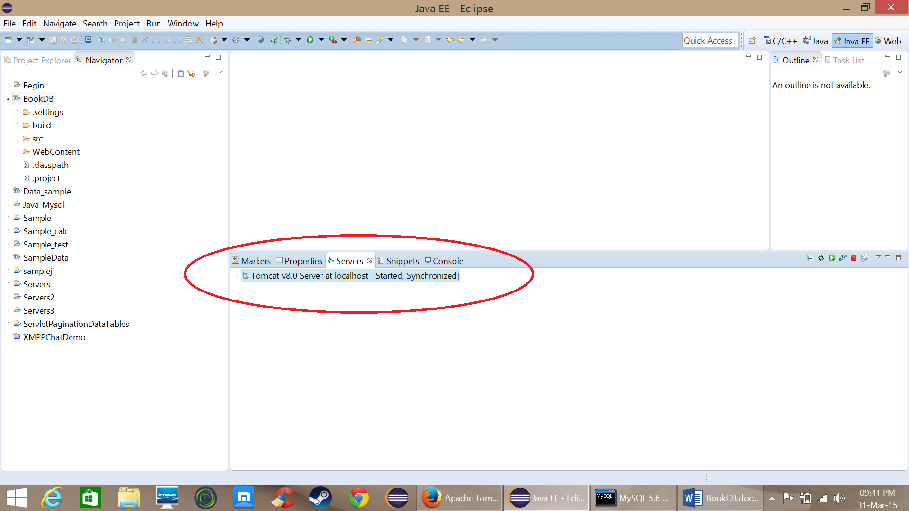Now configure the server in to your IDE (in this case since I am use eclipse I configured it in eclipse)
* 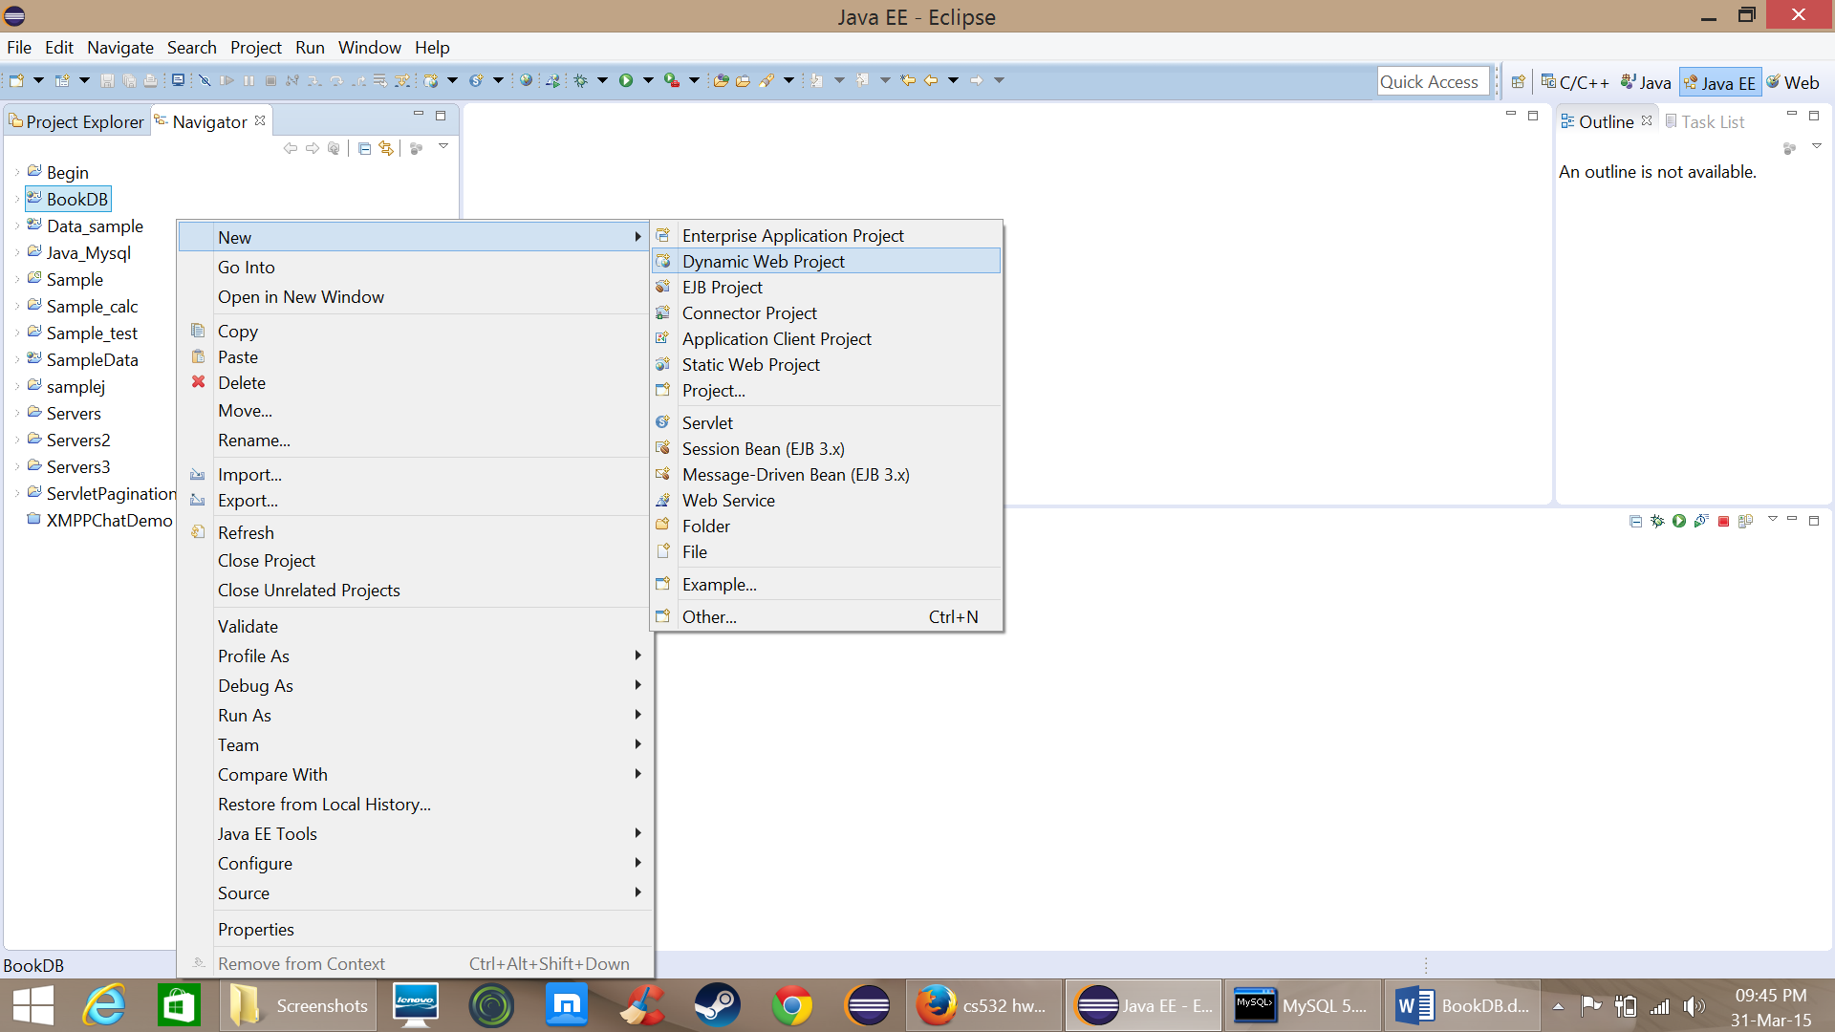Now create a “dynamic web project” and name it as “HelloServlet” and write code to print Hello world

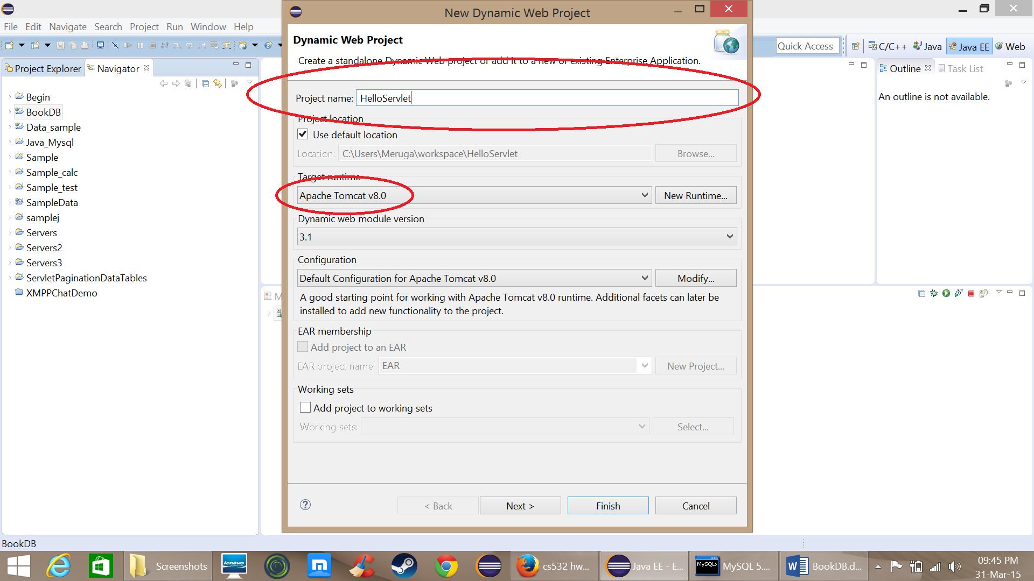

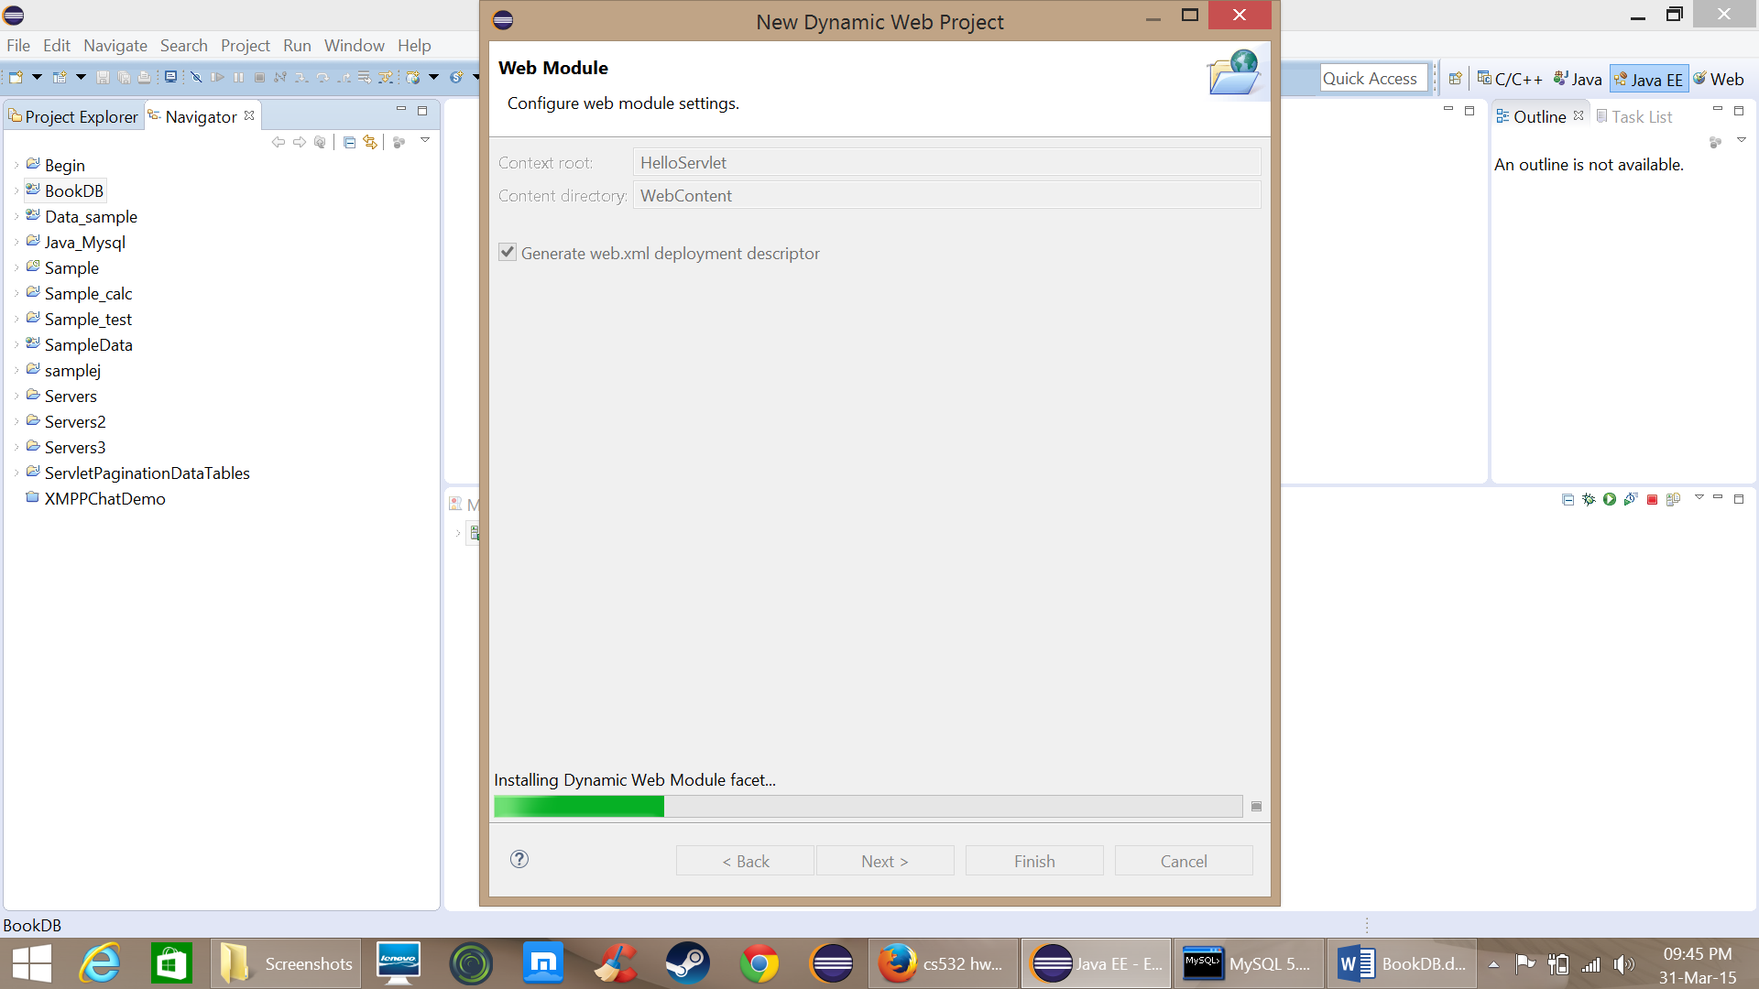

Now create a servlet Hello and write code to display Hello World

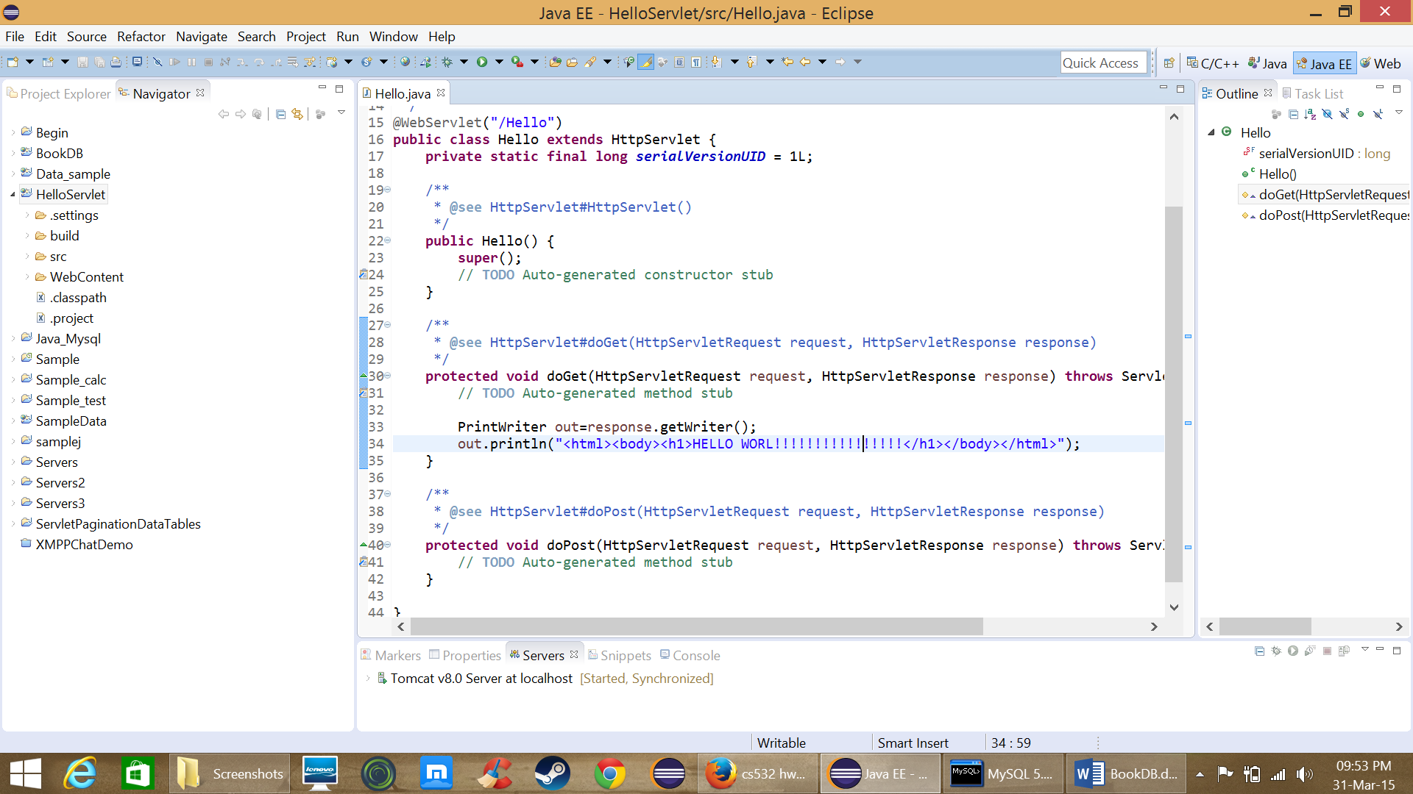

Now run the servlet

It will ask on which server we want to run and select the server you want

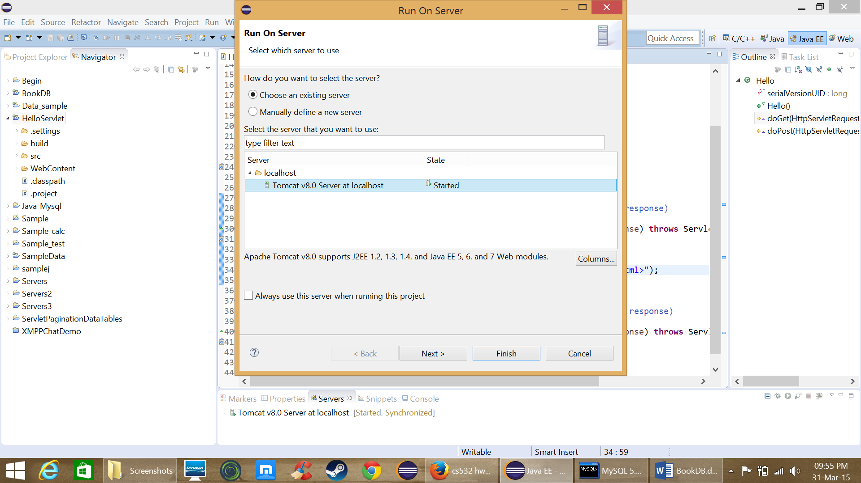

s

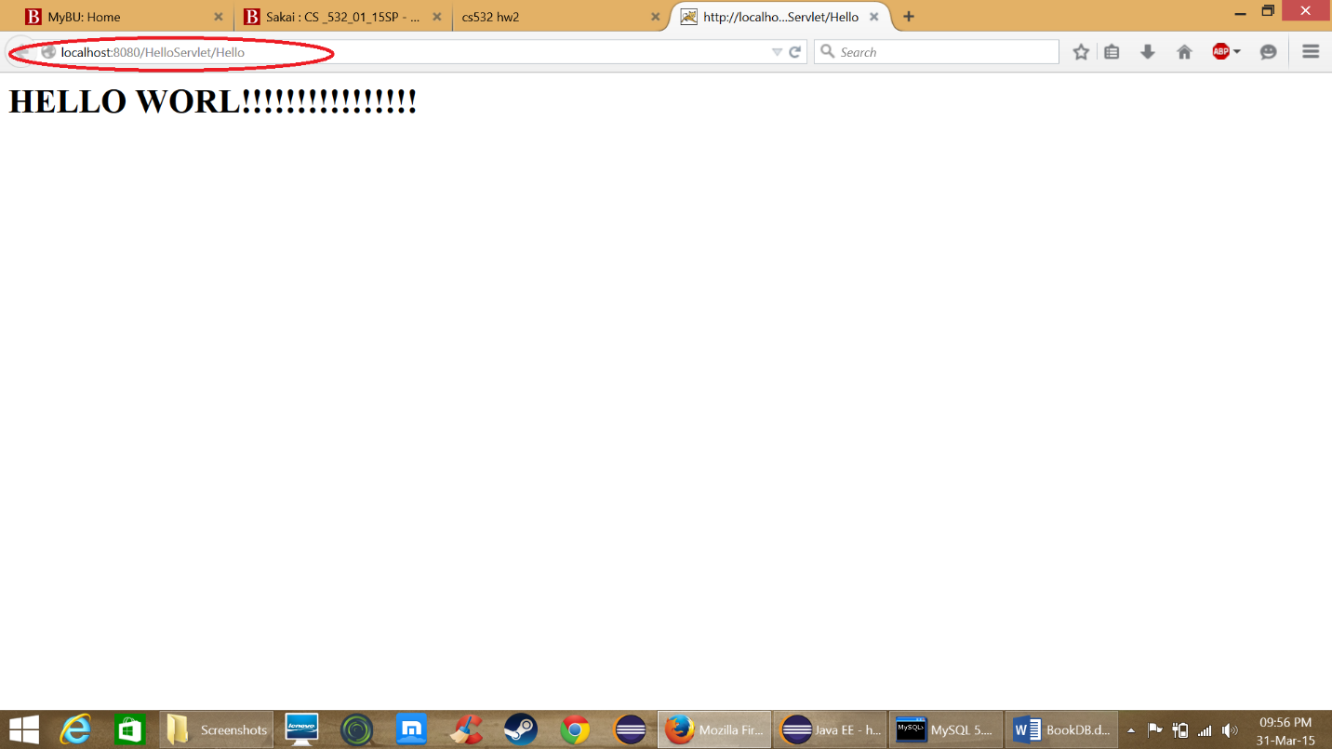

PART – II

* Now similar to part-1 create a dynamic web project and name it as BookDB.
* Now import the java file that is used in assignment 1 “Dbconnect.java” and edit some of the methods by passing “connection” as a variable.
* Create a file index.html as a login page and redirect it to servlet DbSession when user clicks submit button.

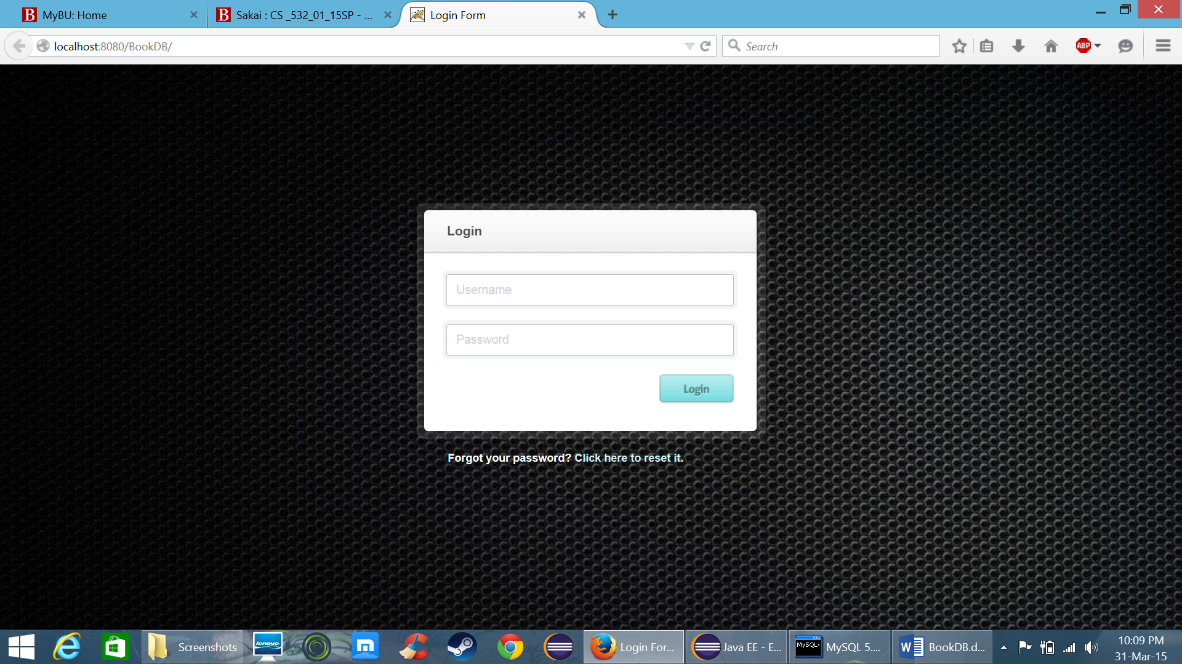

* Now in DbSession servlet store the username and password typed in index.html and create a connection using function from DbConnect.java and save this connection in session so that it can be used throughout the project.
* Now from DbSession if the login credentials are correct redirect it to “main.html” page which got iframe in it.

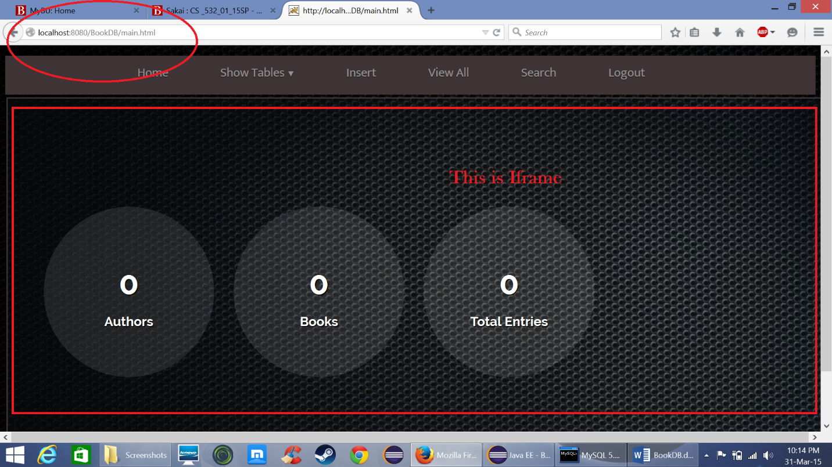

* Whenever the user clicks the menu it displays the servlet in this iframe and the default page in iframe is a servlet that displays the Authors, Books and total entries

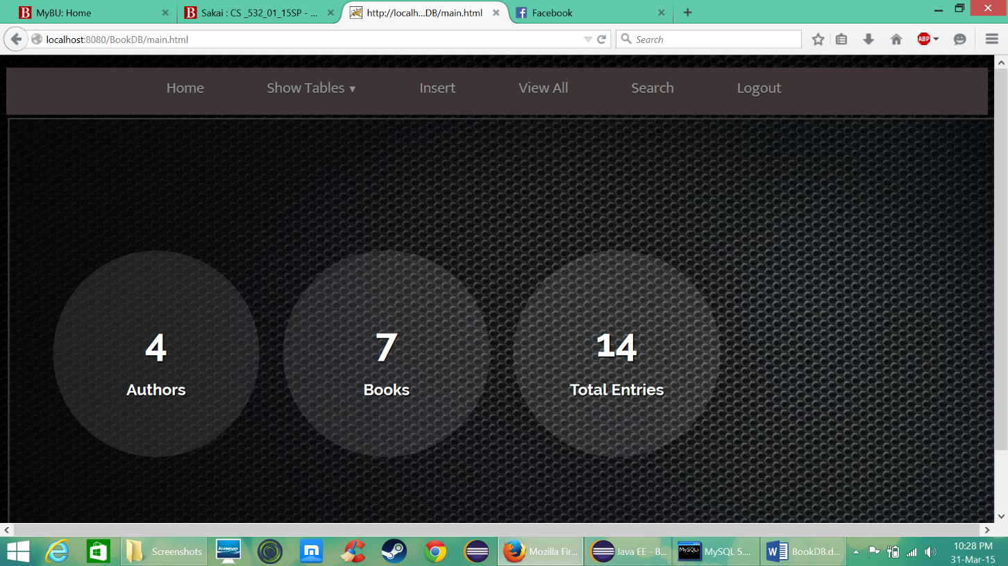

* Now for the “Show Table” there are two options Authors and Titles and when user selects Authors it goes to Tables servlet like “*Tables?table=Authors*” and user selects Titles it goes to Tables servlet like “*Tables?table=Titles*”
* And in the Tables servlet in displays the respective table in html table form

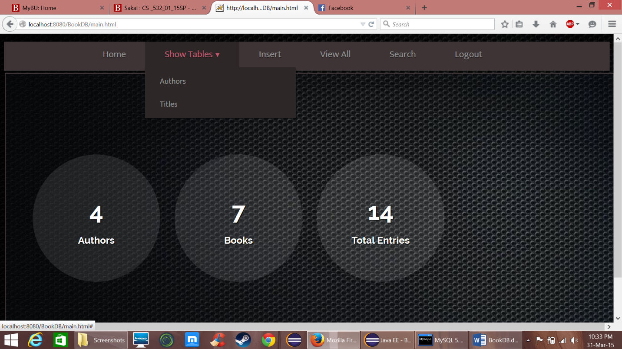

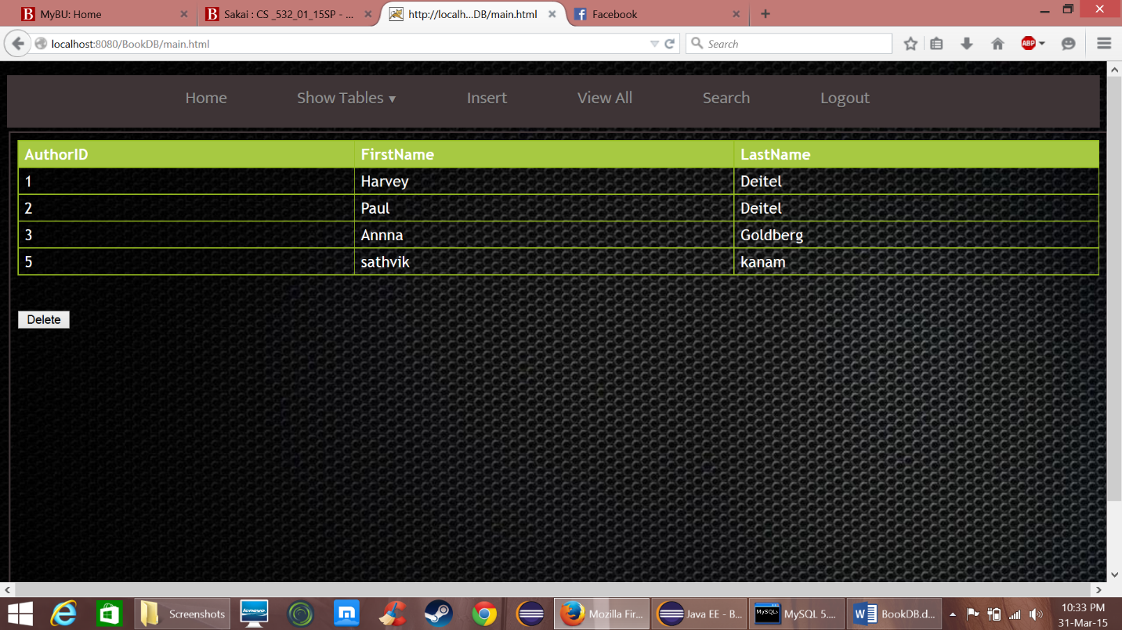

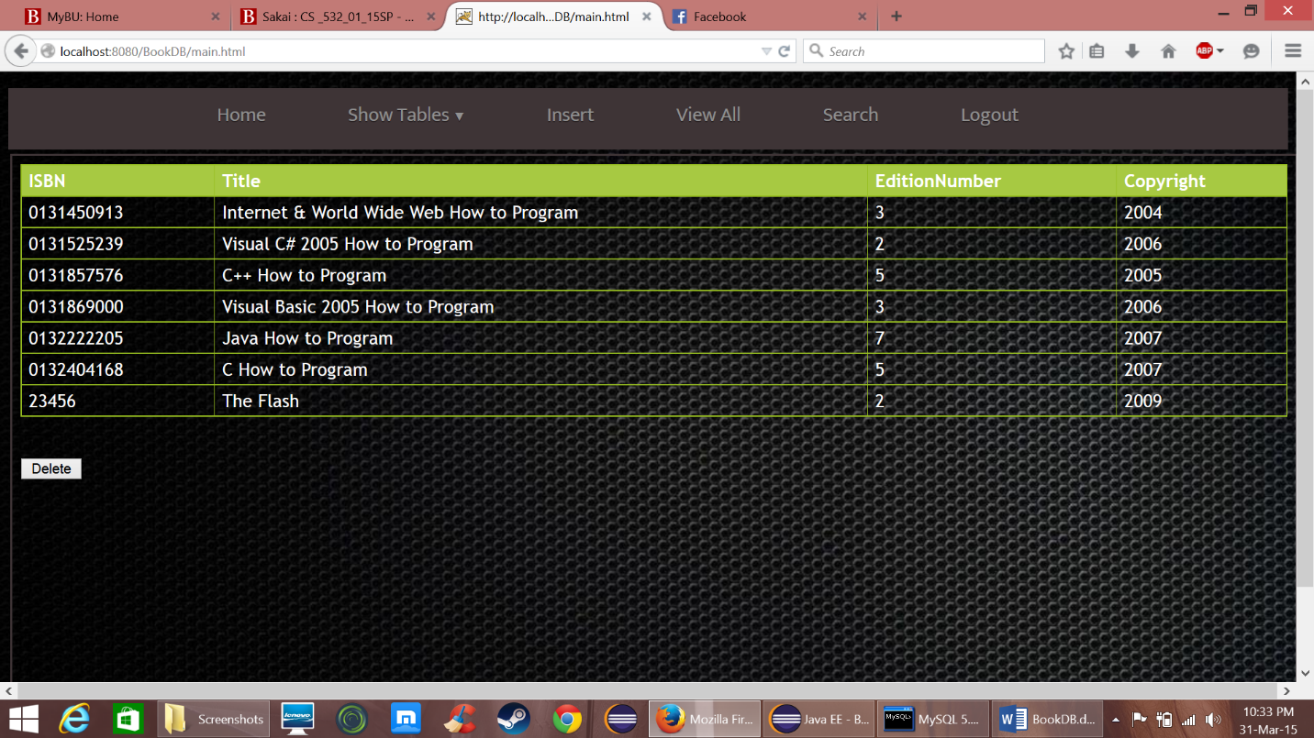

To edit the table just double click on the row and the data will become editable

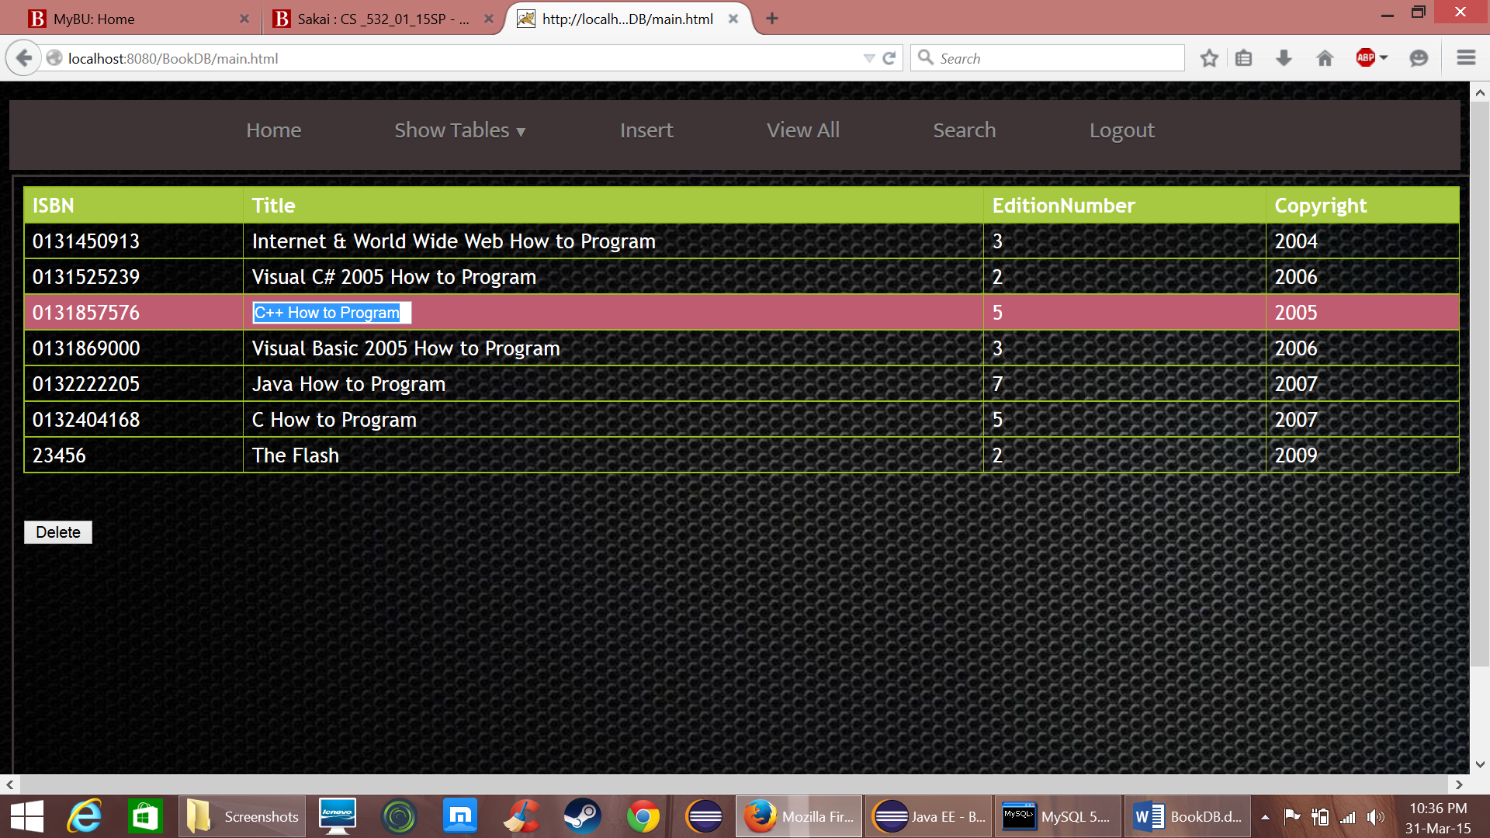

* Similarly to delete select a row and press delete button and it will ask whether you are sure or not
* The updated value is forwarded via javascript to “Updatequery” a servlet that updates the value in DB and redirects to Tables servlet so that it can show tables.

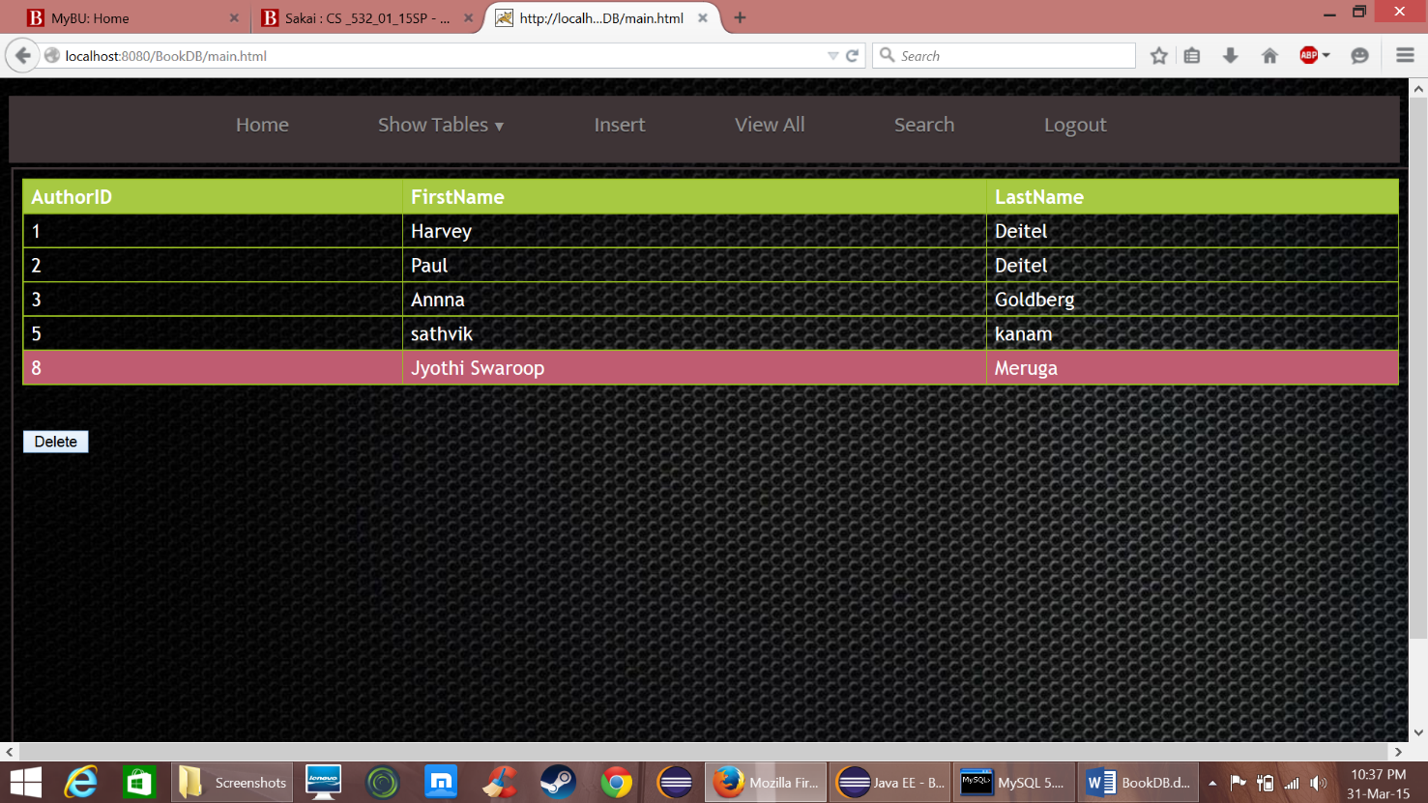

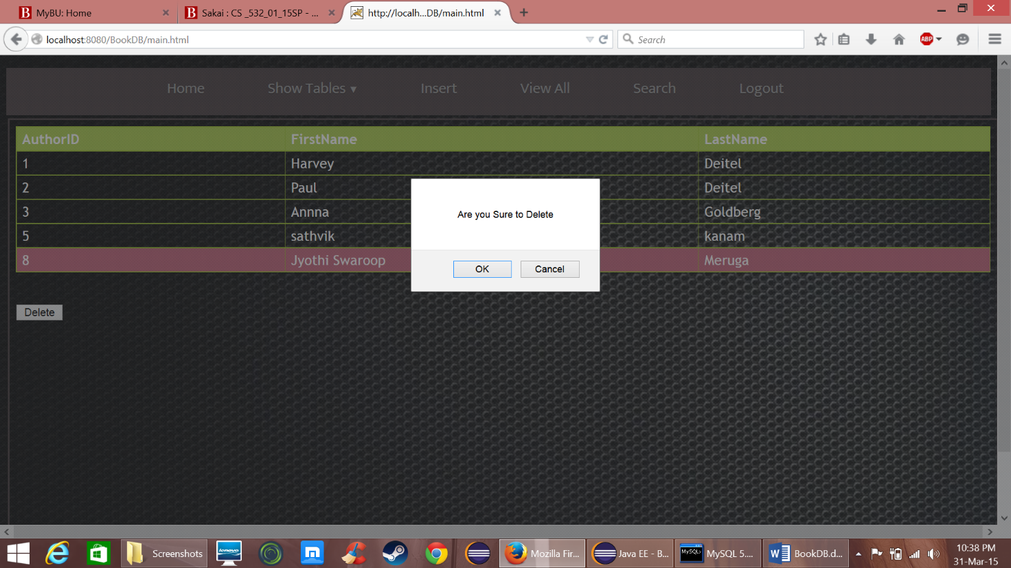

* If you press ok the selected row value is forwarded via JavaScript to “Delete” a servlet used to delete and it redirects again to tables servlet so that it can display
* Similarly for insert a html page is designed

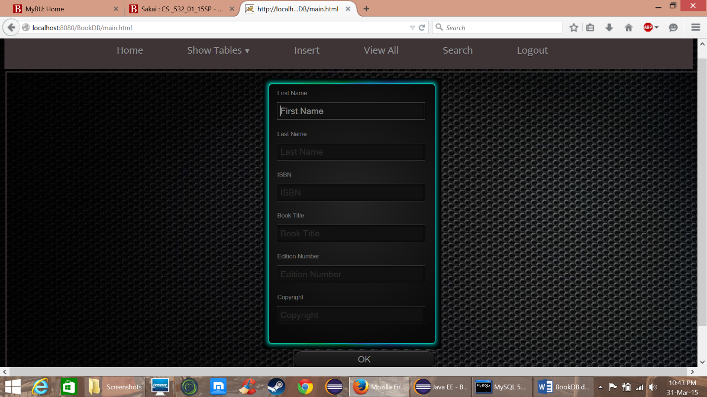

* When the user enters the data and press ok button it goes to “InsertDB” servlet that enters the data into db.

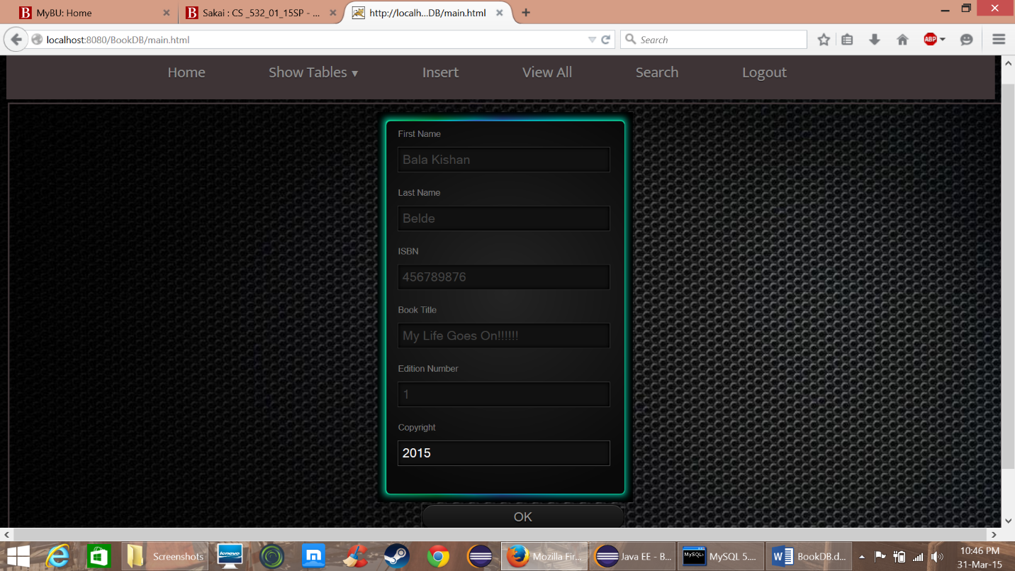

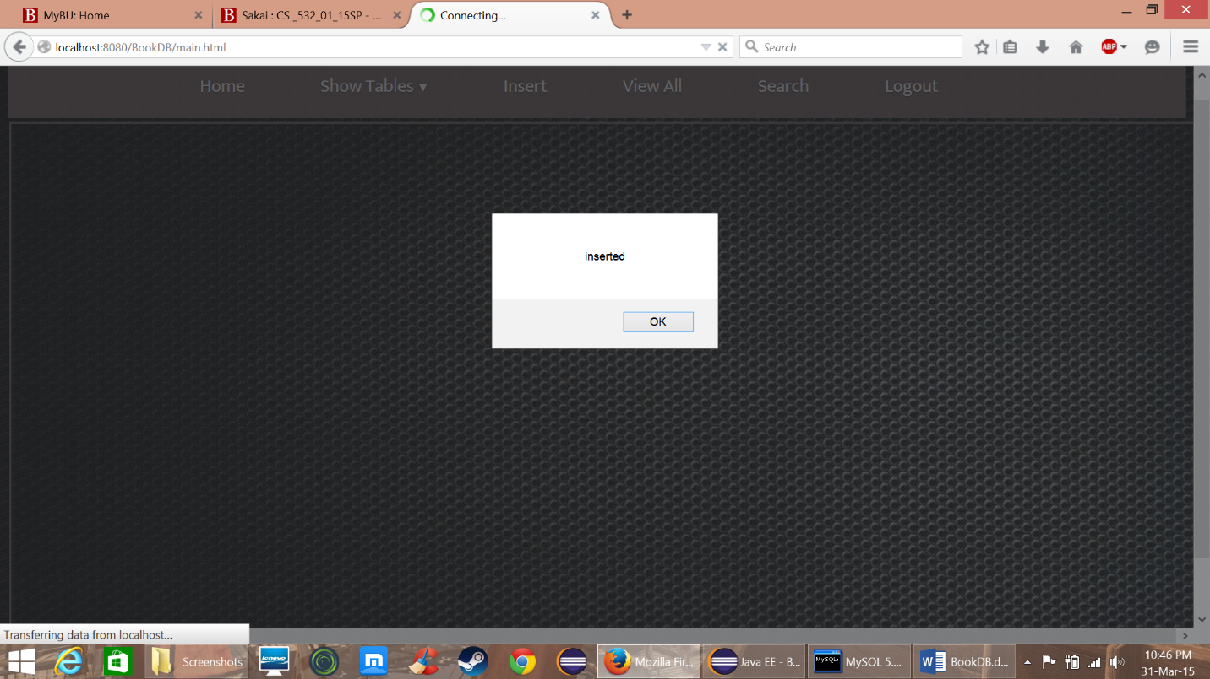

* Now when the user clicks “View All” it goes to “ViewDB” servlet to get data from db and displays it in table.

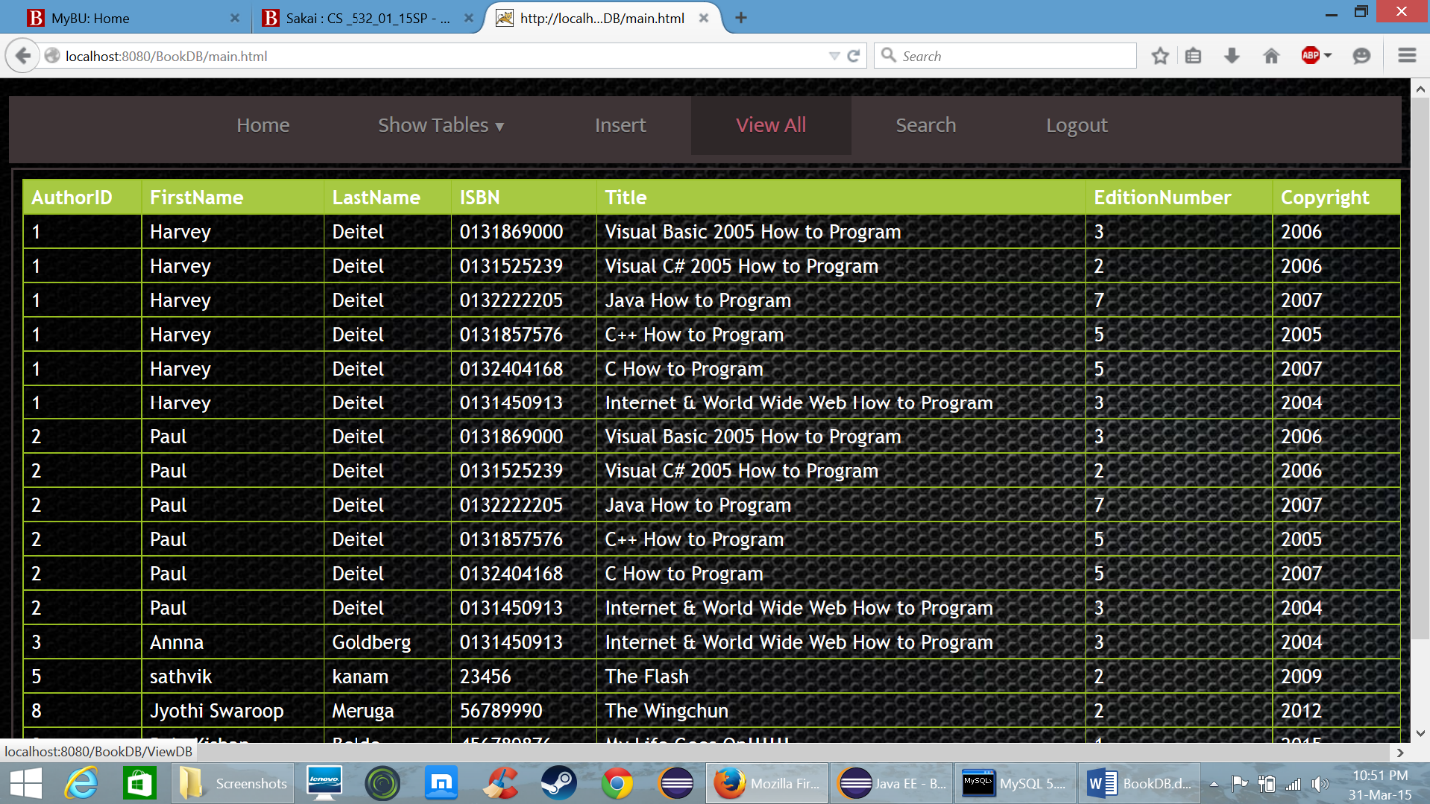

* Now for search design the webpage search.html with an iframe in it

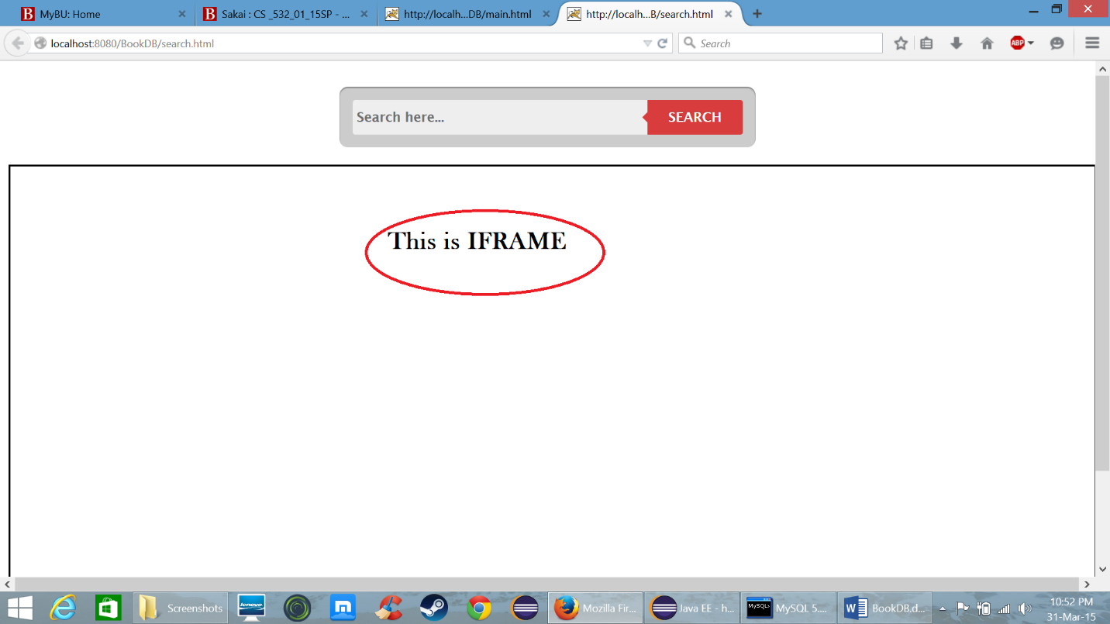

* Now display search.html in iframe of main.html and it looks like this

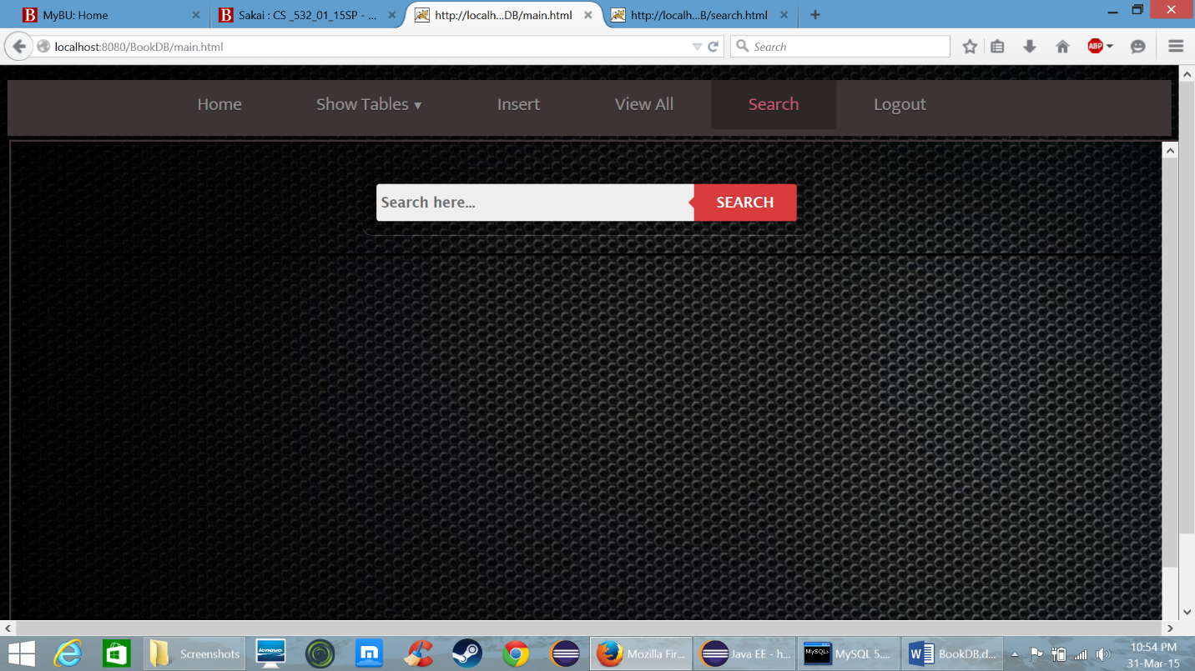

* Now when the user enters any text and presses search button it goes to “SearchDB” and displays the results in iframe of search.html

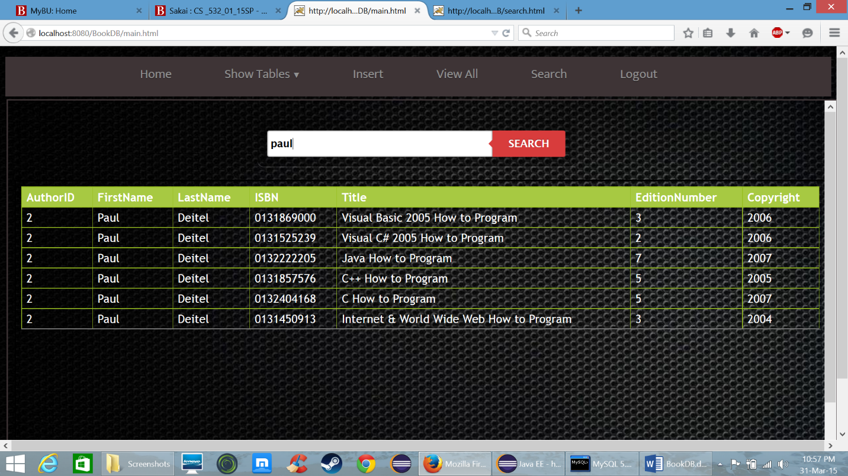

* Now when the user clicks on logout it goes to “Logout” servlet which removes the connection variable from the session and redirects it to login page.

